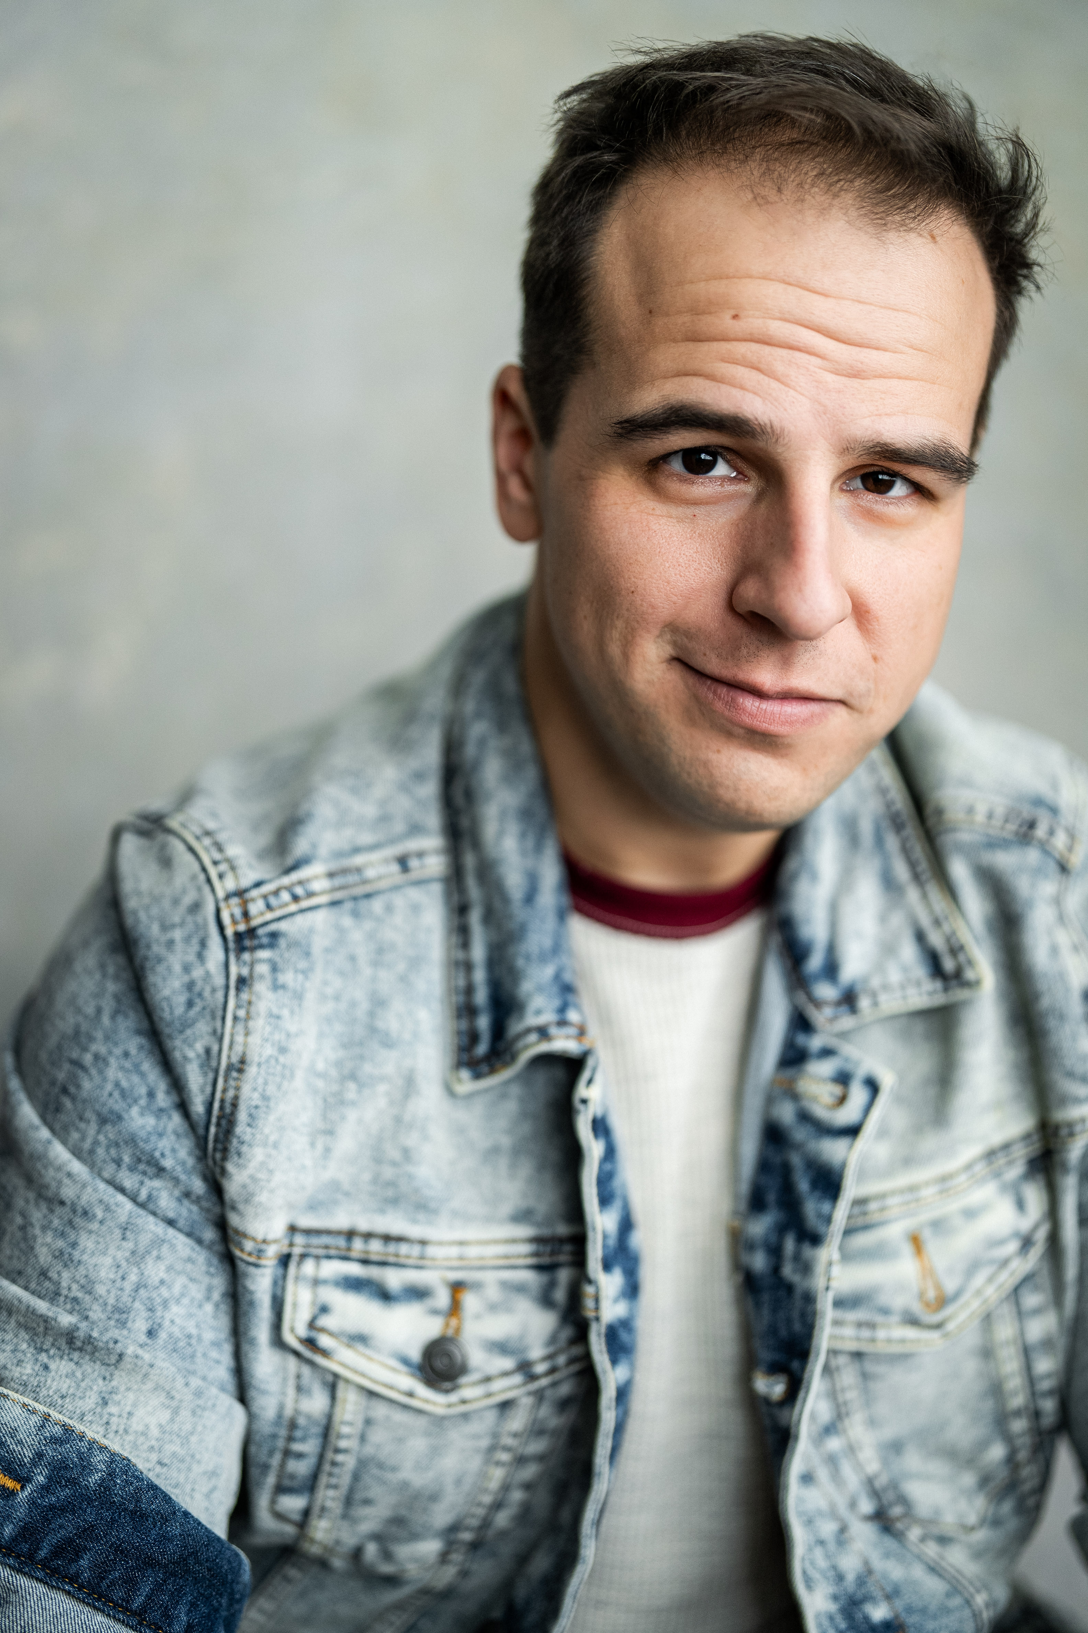
Nicholas David Grevera
Management:
Eileen O'Farrell Personal Management
(818) 985-3136
(AEA/SAG/AFTRA)
https://www.nicholasgreveraofficial.com
ngrevera933@gmail.com
Height- 5’9’’, Hair- Brown, Eyes- Brown, Vocal Range –Tenor
Stage Credits
I Love You, You’re Perfect, Now Change. Man 1 Lake George DT Jarel Davidow
All Shook Up Jim Haller The Lucas Theatre Tiffany Evariste
I Love You, You’re Perfect, Now Change. Man 2 The Judson Theatre Co. Morgan Sills/Daniel Haley
Executive Dance Steve The Mondanaro Theatre Craig Anton
I Love You, You’re Perfect, Now Change. Man 2 The Theatre Barn Paul Urriola
Great American Trailer Park Musical Norbert Garstecki The Theatre Barn Kevin Wallace
Lucky Stiff Ensemble The Theatre Barn. Robert W Schneider
Songs For A New World Man 2 Sette La Verghetta Theatre Chuck Gordon
The Glass Menagerie Tom The Mondanaro Theatre Cameron Lopez
Everyman Undertaker 2 The Sentient Bean Trevor Browning
Bald Soprano Mr. Martin Hamilton Theatre Craig Anton
Sense and Sensibility Lady Middleton Arnold Theatre Victoria Mack
Hand to God Pastor Greg The Grove Theatre Kelly Kriger
Film Credits
Murder under the Friday Night Lights Detective Investigation Discovery
Inanimate (Short Film) Steve MegaManMedia Production
HBO Max Special AD Jim Kenzie Uhr Productions
Matt and Spratt Take Jersey City Spratt Jackie Fiorillo Productions
Absolutely Ridiculous Birthday Dad Laura Mason Productions

Education
MFA - Performing Arts SCAD – 2022 (Savannah College of Art and Design)
BA in Theatre Arts Marywood University – 2016
The Magnet Theatre(NYC) Internship. (2024-)
Vocal Coach Kevin Wallace Acting – Realism John Prosky
Acting - On Camera Craig Anton and Scott Alen Smith Stage Combat Maura Malloy
Acting – Classical and Period Joan McMurtery Musical Theatre Dance LaToya Martin
Acting – Absurdist Mary Kelly Improv Comedy David Stork
Acting - Meisner Method Mary Ethel Schmidt Commedia Dell’arte Angelo Crotti

Skills/ Miscellaneous
Vocalist (Tenor-Baritone) Intermediate Piano Ukulele
Certified Firefighter in the U.S. . Philadelphia Eagles Fan, “Go Birds!!” Character Voices/impressions CPR/First Aid Certified Valid PA Driver’s License Valid US. Passport Casual Roller-Skate/Blade Gilbert Gottfried Impression Amateur Golfer

